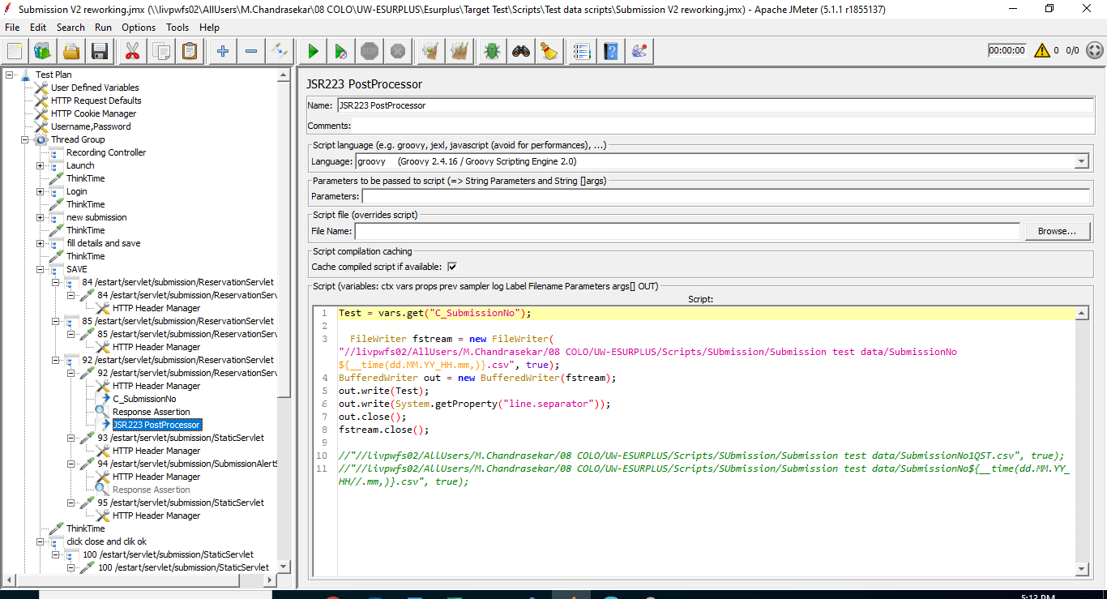

Test = vars.get("C_SubmissionNo");

FileWriter fstream = new FileWriter("//livpwfs02/AllUsers/M.Chandrasekar/08 COLO/UW-ESURPLUS/Scripts/SUbmission/Submission test data/SubmissionNo${__time(dd.MM.YY_HH.mm,)}.csv", true);

BufferedWriter out = new BufferedWriter(fstream);

out.write(Test);

out.write(System.getProperty("line.separator"));

out.close();

fstream.close();

//"//livpwfs02/AllUsers/M.Chandrasekar/08 COLO/UW-ESURPLUS/Scripts/SUbmission/Submission test data/SubmissionNo1QST.csv", true);

//"//livpwfs02/AllUsers/M.Chandrasekar/08 COLO/UW-ESURPLUS/Scripts/SUbmission/Submission test data/SubmissionNo${__time(dd.MM.YY_HH//.mm,)}.csv", true);

Loadrunner:

 rc = lrvtc_connect("10.185.49.139", 8894, VTOPT_KEEP_ALIVE);

after correlation

lrvtc_send_row1("c_registration_id","{C_Reg_Id}",";",VTSEND_SAME_ROW);

in data required script

rc = lrvtc_connect("10.185.49.139", 8894, VTOPT_KEEP_ALIVE);   
   
    lr_log_message("RC returns %s",rc);  
  
    lrvtc_retrieve_messages1("c_registration_id",";");  
      
    lr_log_message("registration id is %s",lr_eval_string("{c_registration_id}"));